**__________________________________________________________________________________**

**Emp Name** : **Ankita Jalindar Chavan**

**Emp Id : 46218941**

* **Why Jenkins??**

Jenkins is used to build and test your product continuously, so developers can continuously integrate changes into the build.

Jenkins is the most popular open source CI/CD tool on the market today and is used in support of DevOps,and other cloud native tools.

* **Architecture of Jenkins:**

Windows Slave Node

Jenkins Master(UI)

Apple OSX Slave Node

**TCP Connection**

Linux Slave Node

* Developers commit changes to the source code, found in the repository.
* The Jenkins CI server checks the repository at regular intervals and pulls any

newly available code.

* The Build Server builds the code into an executable file. In case the build fails,

feedback is sent to the developers.

* Jenkins deploys the build application to the test server. if the test fails,the developers are alerted.
* If the code is error free, the tested application is deployed on the production

server

* **Installation Steps:**

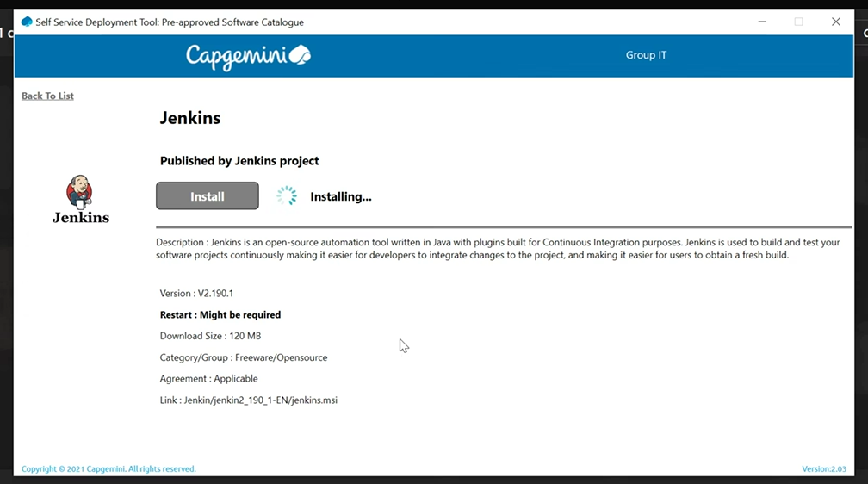

### Step 1: Download Jenkins

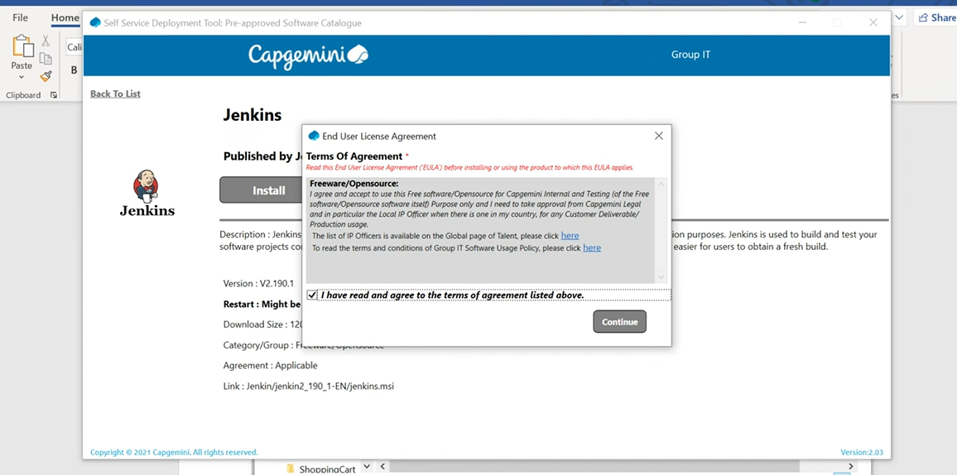

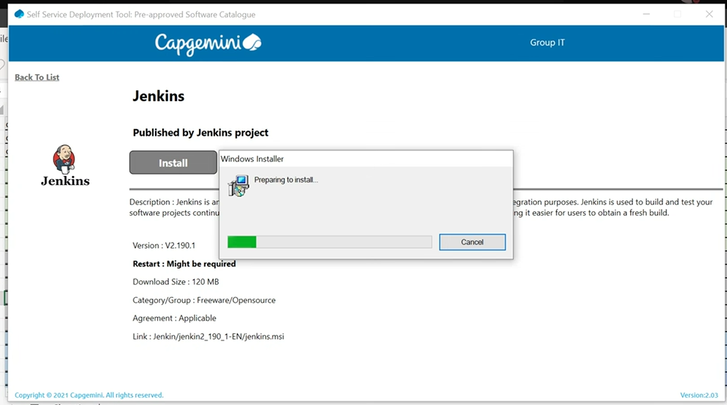

Run the installer

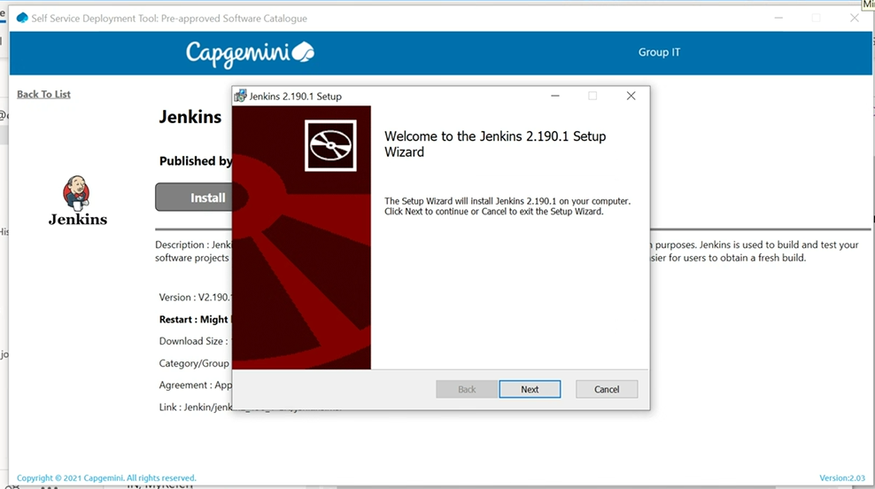

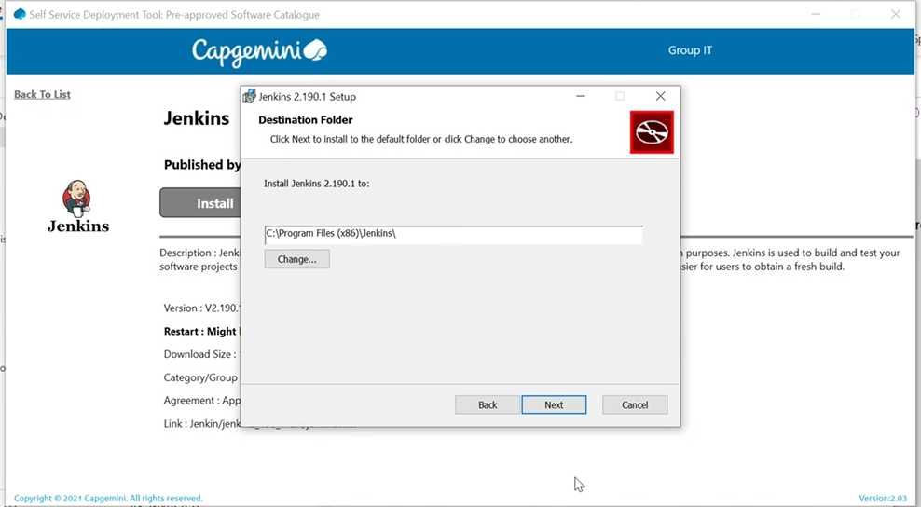

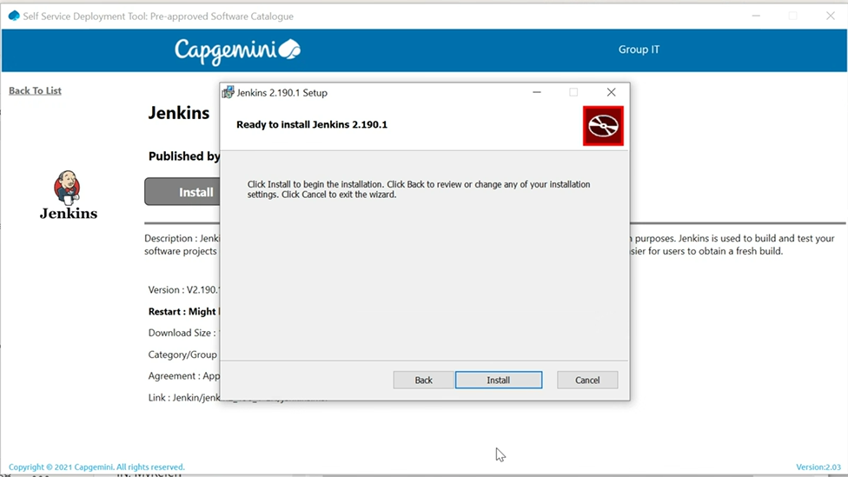

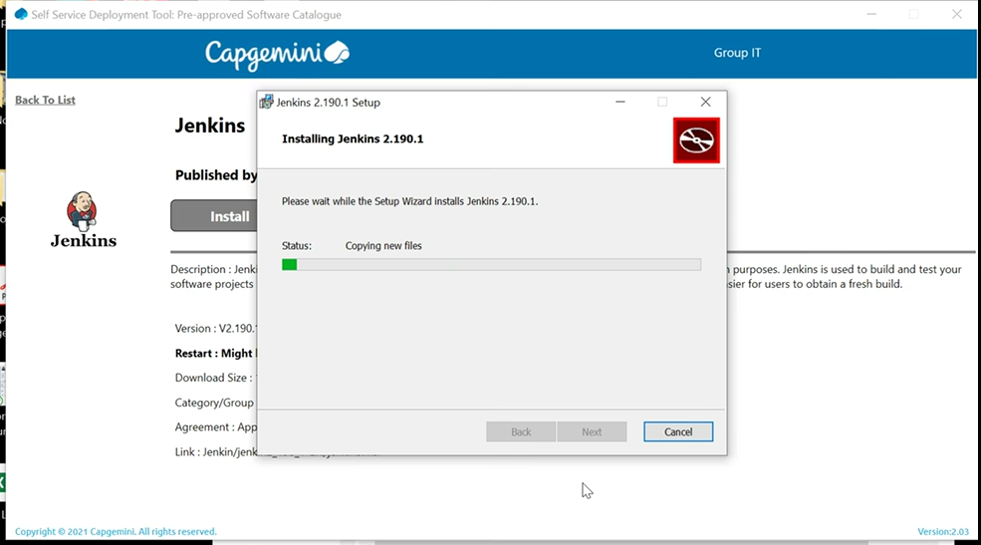

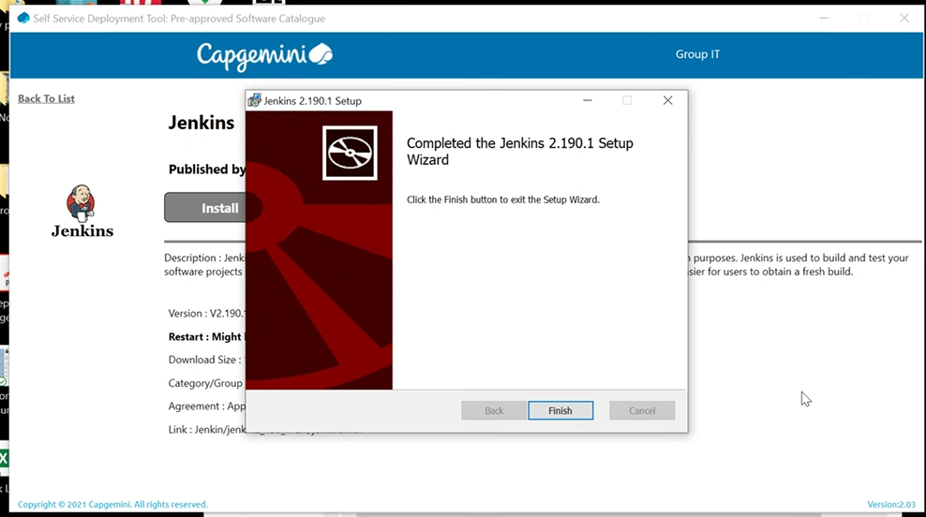

### Get the installation password

As soon as the installation is complete, it will open a new browser page pointing to this URL: http://localhost:8080/

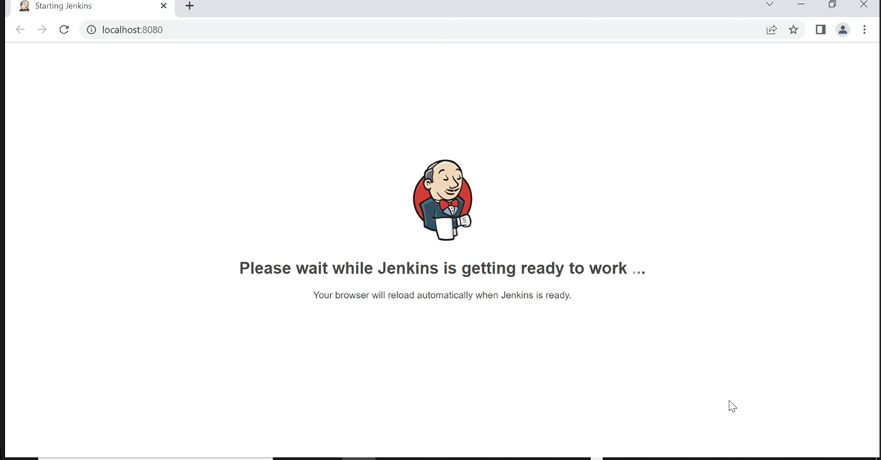

Next, we need to open the file mentioned (initialAdminPassword) with Notepad or any other text editor and copy the password.

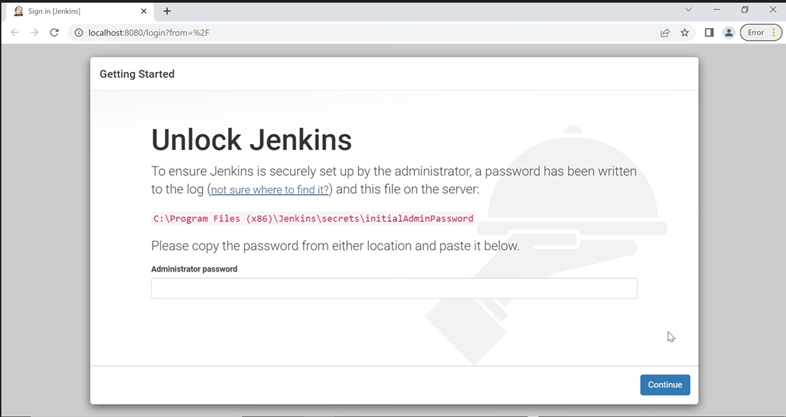

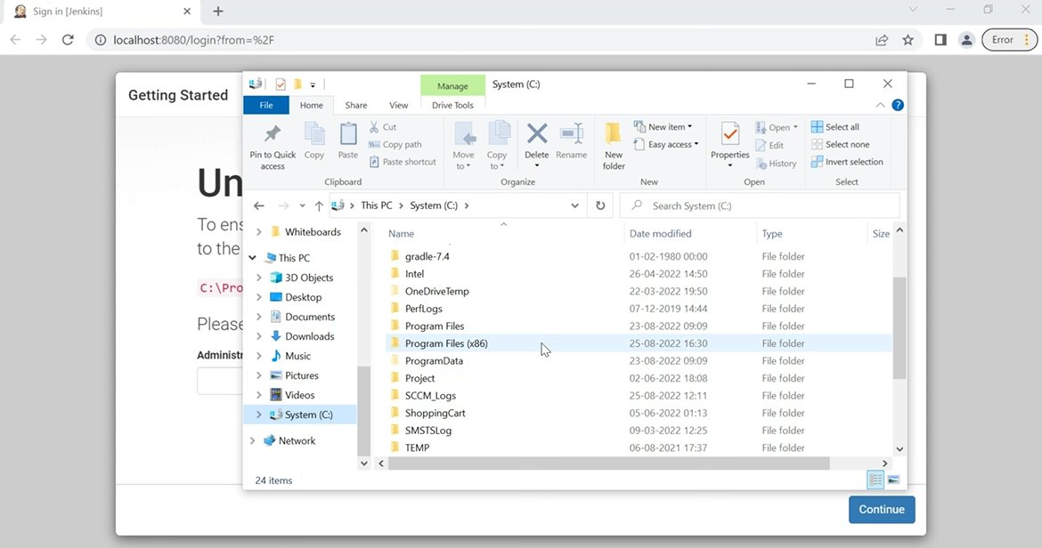

Open the below folder (as per your system folder structure) and secret key file

C:\Program Files (x86)\Jenkins\secrets

File name : initialAdminPassword

Copy the secret key from here and paste it in the bowser Administrator password textbox (0b082742481b4467b6bbc178dceb2351) and continue

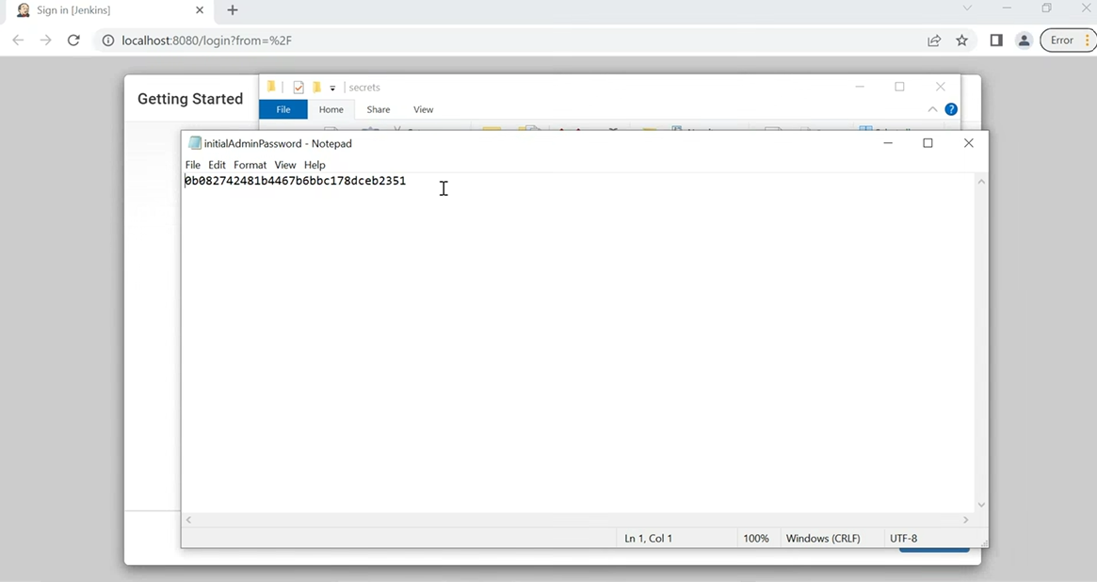

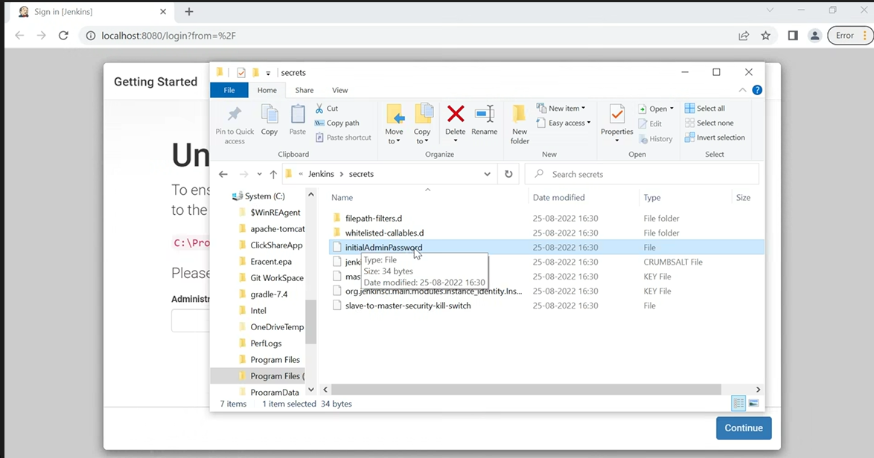

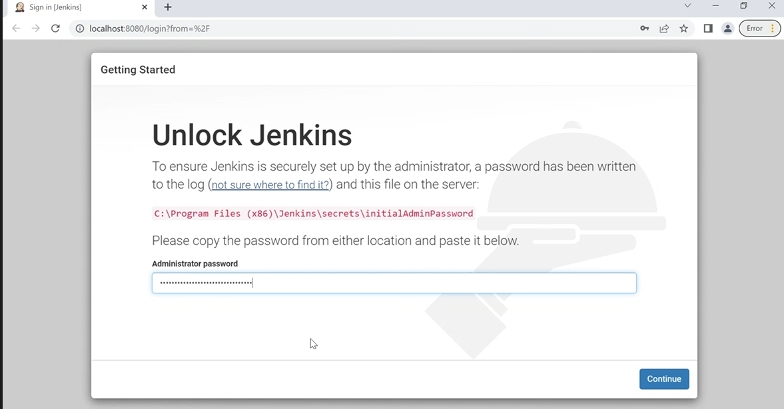

Let’s Configure Jenkins now

Once you have installed Jenkins in any of the ways presented, it is time to do the final setup.

### Step 4: Install plugins

Jenkins is composed of multiple components called plugins. The next step asks which plugins we would like to install. Just install the suggested plugins.

Install suggested plugins

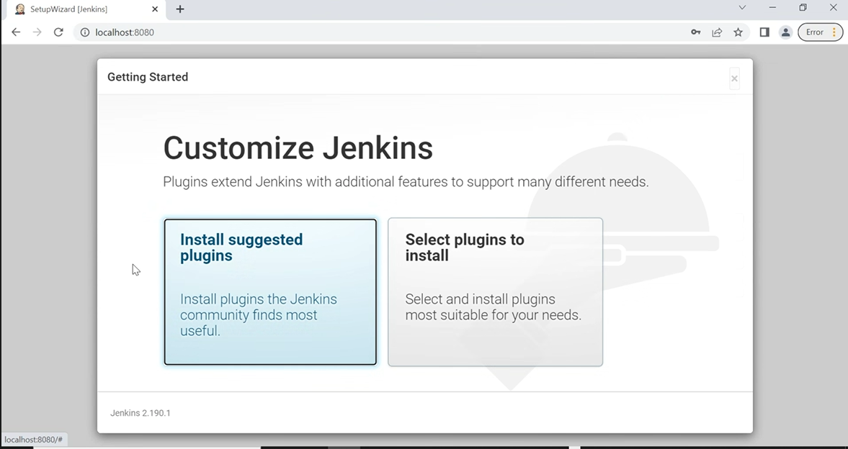

**Select Install suggested plugins**

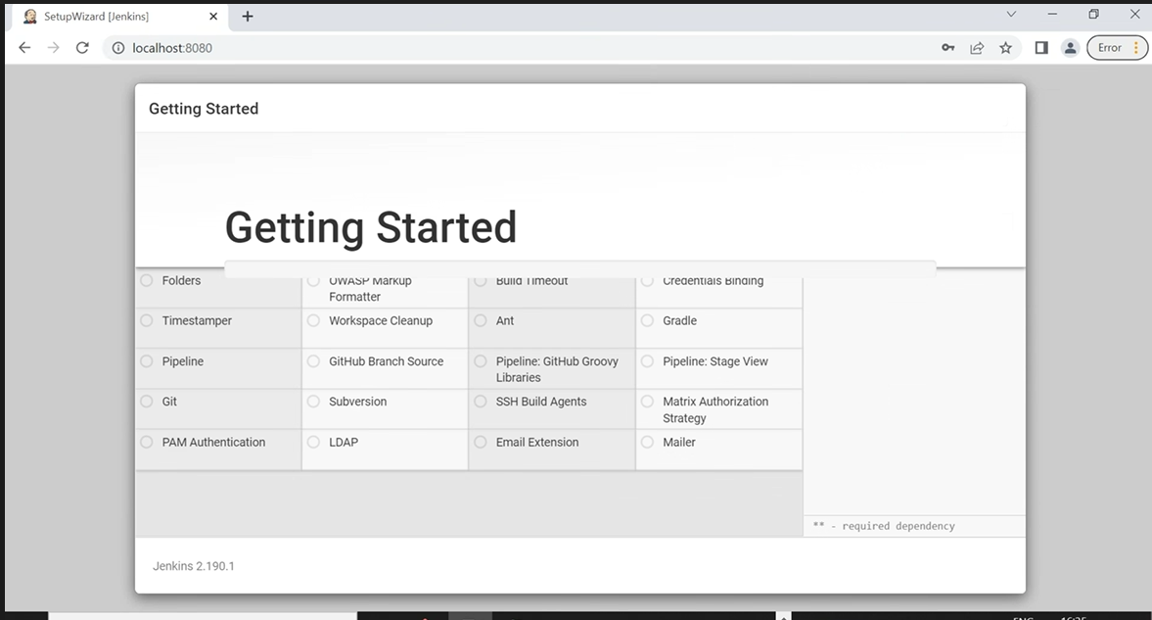

Once we have installed Jenkins in any of the ways presented, it is time to do the final setup.

### Configure the Jenkins URL

The final step is to configure the URL for the Jenkins server. This would be prefilled for you. So, all we need to do is to click “**Save and finish**“.

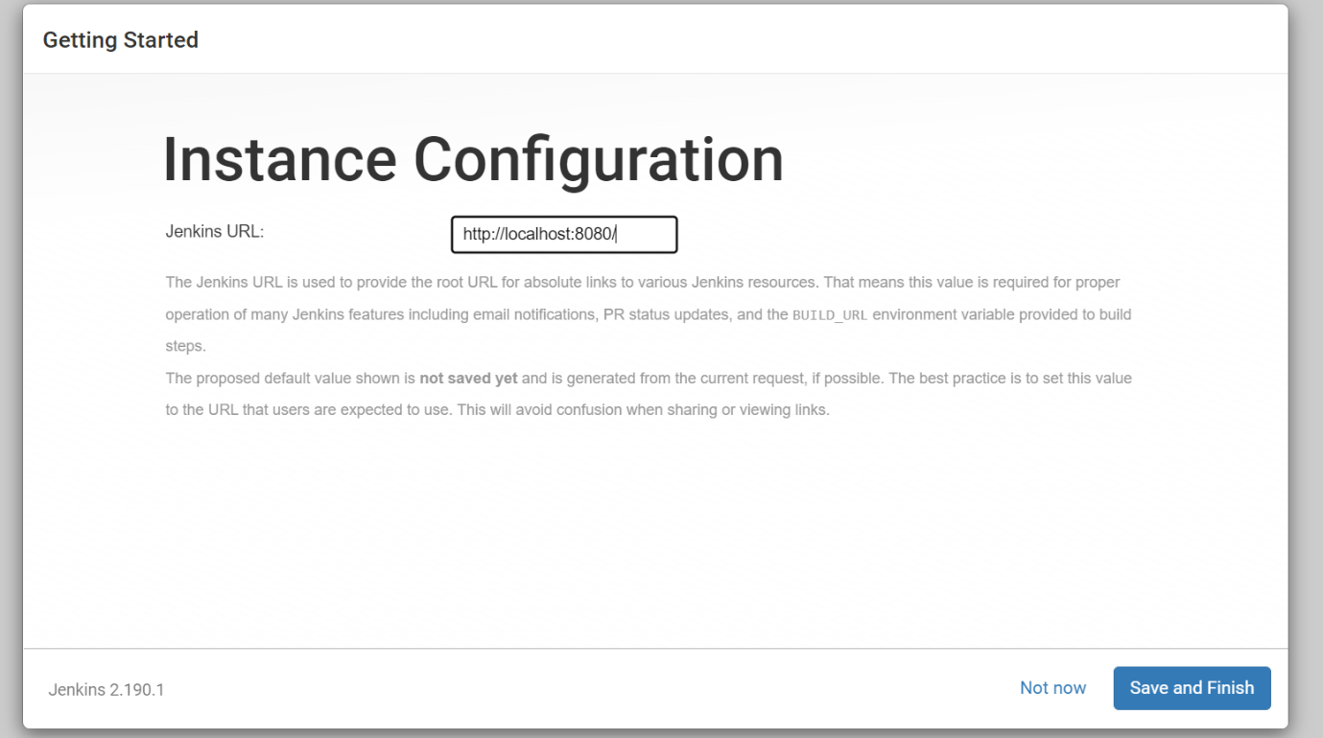

### Now you are all set to use Jenkins

### 

**Create new Project**

### 

### Now we are all set to use Jenkins

### 